Purpose: This laboratory exercise is intended to give the student knowledge and experience in working with motion control principles using a stepper motor. In addition, the student will learn the benefits of various step sizes and speed of response control.
Background: In industry, there are many applications that require exact positioning. This is carried out by two different types of motors and motor drive systems. One type is Stepper Motors and the other is Servo Motors. This lab deals exclusively with Stepper Motors.
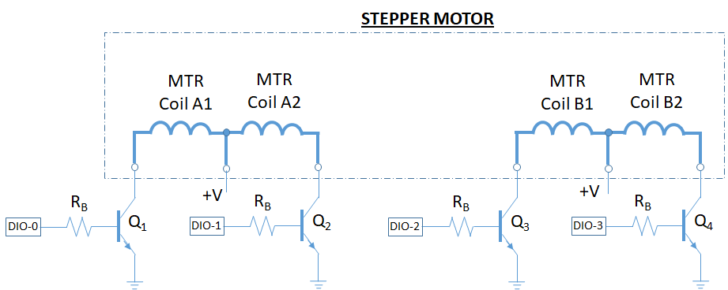
Figure #1: NPN and PNP Output Load Control
Stepper motors are commonly found in applications where a home position is a starting and ending point. The home position provides the motor and controls a reference point from which the motor can drive from and return after accomplishing a task. For example, a manufacturing process may require a table that holds a part to be moved into a particular position using a ball screw. The stepper motor can essentially count the number of steps to get the table into position. Once the part is finished processing, then the table can return to the starting position.
The primary method of control is to use the NPN or PNP driving transistors as shown in Figure #2. Referring to these figures, the Load represents the coil of a stepper motor. When the NPN or PNP device has voltage applied to the base, then the collector to emitter channel turns on and behaves like a switch. (The transistor is in saturation mode.) A resistor is typically placed in the base of the transistor to limit the current to the base, but the resistor is sized such that the transistor will enter saturation when turned on.
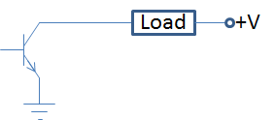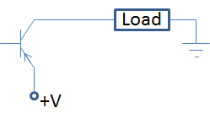
Figure #2: NPN and PNP Output Load Control
By measuring the DC resistance of the motor coil (load), the collector current can be computed from I_{C} = V/R_{coil}. Knowing the transistor BETA (current gain, IC/IB), then the base current can be computed, I_{B}=I_{C}/β. Finally, if the transistor is in saturation, then the base voltage will be 0.7V, which results in a 4.3V across the series Base Resistor (assuming the ON voltage from the base controller is 5V). The resistance is computed as 4.3V/I_{B}.
This lab exercise will introduce the student to stepper motor, controls, and operation. The student will learn how to identify coil pairs, measure coil resistance, connect these devices to a controller, and the impact of different sequencing to improve step precision and speed,

Procedure: 1. Using a DMM ohmmeter, identify the two different Stepper Motor coils
(A and B) and label the wire colors below:

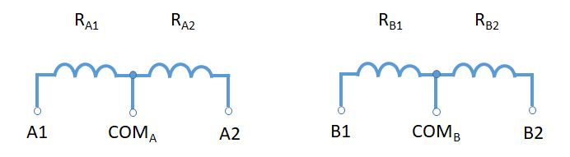

Coil | Resistance | Terminal | Wire Color
A1 – COM | 103.7 ohms | COM_{A} | black
A2 – COM | 104.5 ohms | A1 | red
A1 – A2 | 208 ohms | A2 | blue
B1 – COM | 103 ohms | COM_{B} | white
B2 – COM | 103.4 ohms | B1 | brown
B1 – B2 | 206.4 ohms | B2 | yellow

2. For the stepper motor control circuit shown in Figure #1, the supply
voltage is +12 VDC and the base voltage is 0 or 5VDC. Calculate the size of the current limiting resistor, R_{B}, required for the transistor control circuit. Use an average value of coil resistance when performing the collector current calculation. Also, use a Beta of 50 for the transistor. Select the standard resistor that is equal to or below he resistor calculated.

Resistor, R_{B} | 1894.9 ohms

3. Using the NI-ELVIS board, a stepper motor, (4) resistors as calculated in step #2, and (4) 2N3904 transistors (NPN), build the circuit shown. Open the LabVIEW program provided by the instructor.
a. Select the Wave sequence option from the LabVIEW front panel.
Also, execute the program at very slow rates (Step Time Slider bar). Record your observations of the differences between the sequences.

Table : Wave Steps

Q1 | Q2 | Q3 | Q4
X | 0 | 0 | 0
0 | 0 | 0 | X
0 | X | 0 | 0
0 | 0 | X | 0
X | 0 | 0 | 0

b. Select the Full Step mode sequence. Use a very slow speed (1 second per step), a medium (500ms per step), and a fast speed (25-50 micro=seconds per step). Record your observations of the sequence.

Table: Four Step Input Sequence, Full Step

Q1 | Q2 | Q3 | Q4
X | 0 | X | 0
X | 0 | 0 | X
0 | X | 0 | X
0 | X | X | 0
X | 0 | X | 0

c. Select the Full Step mode sequence. Use a very slow speed (1
second per step), a medium (500ms per step), and a fast speed (25-50 micro=seconds per step). Record your observations of the sequence.

Table : Eight Step Input Sequence, Half Step

Q1 | Q2 | Q3 | Q4
X | 0 | X | 0
X | 0 | 0 | 0
X | 0 | 0 | X
0 | 0 | 0 | X
0 | X | 0 | X
0 | X | 0 | 0
0 | X | X | 0
0 | 0 | X | 0
X | 0 | X | 0

Observations:

